The interview with my client, Yubo Su, was in Chinese. Here is the English translation:

Me: Hello Yubo, I am planning to make a game for my computer science project, and you would be my client. Do you have some game that you want to play?

Yubo: Something like the Dark Soul?

Me: Be realistic. I am not a game designer, I am really sure the game I can make will not be so complicated. So do you need some minigames...like bingo or tic-tac-toe.

Yubo: A tic-tac-toe would be interesting, but why don’t we play it just on paper and pen?

Me: Ya…

Yubo: Oh, I see the problem. Do you remember that we had once play tic-tac-toe during honour pass time? We found that the first player cannot lose.

Me: I lost a lot last time.

Yubo: So this game is really unfair. Why don’t you make a modified version of that? And that is really what I need, for a game to play during honour pass times.

Me: To make the complicated version, I think making more cells is enough.

Yubo: But then it would be the same as the Gomoku. You know, the five-piece game?

Me: Or we can add one more player. Three player tic-tac-toe.

Yubo: But where can I find the third player and the board will be filled in only three turns.

Me: How about a 3D version, like a Rubik's Cube?

Yubo: You mean like a 3x3x3 cube? That is a good idea. I saw some tic-tac-toe with multiple layers represented as three 3x3 boards, that is so stupid, and I can still do that on paper. So I wish that I can have an actual 3D model and can turn the cube to face other directions.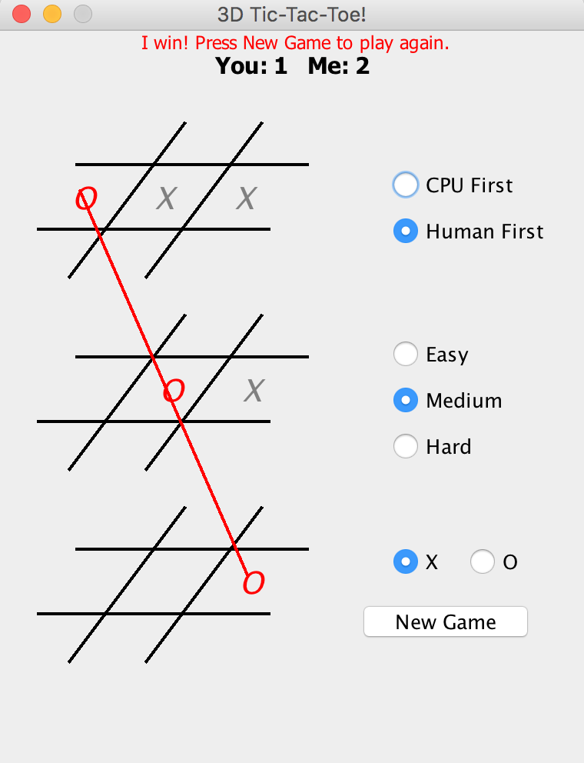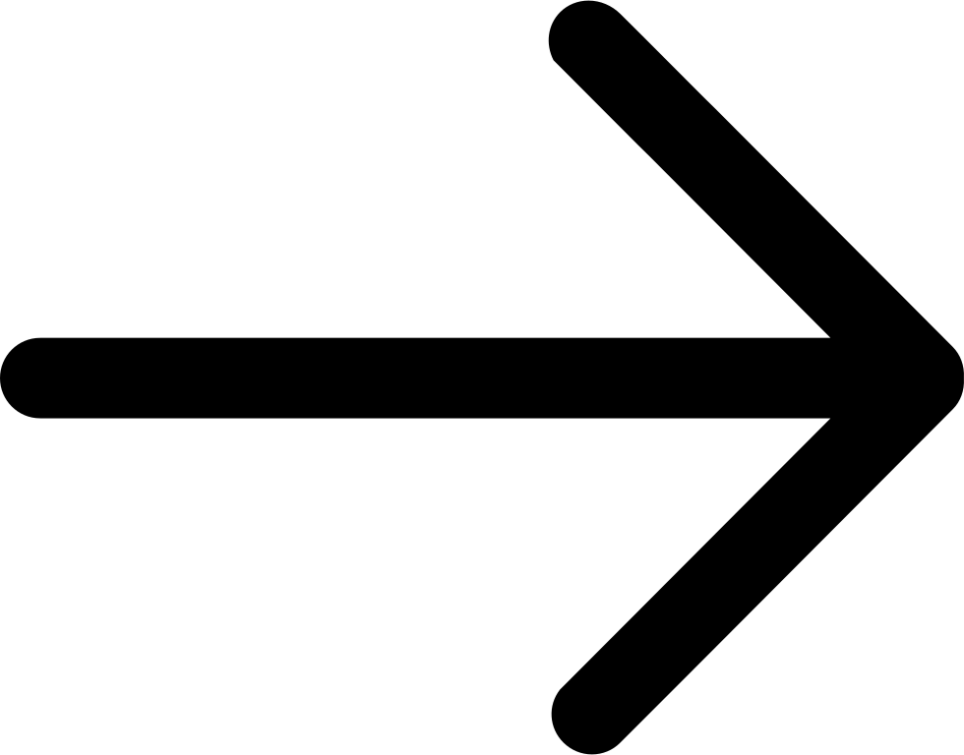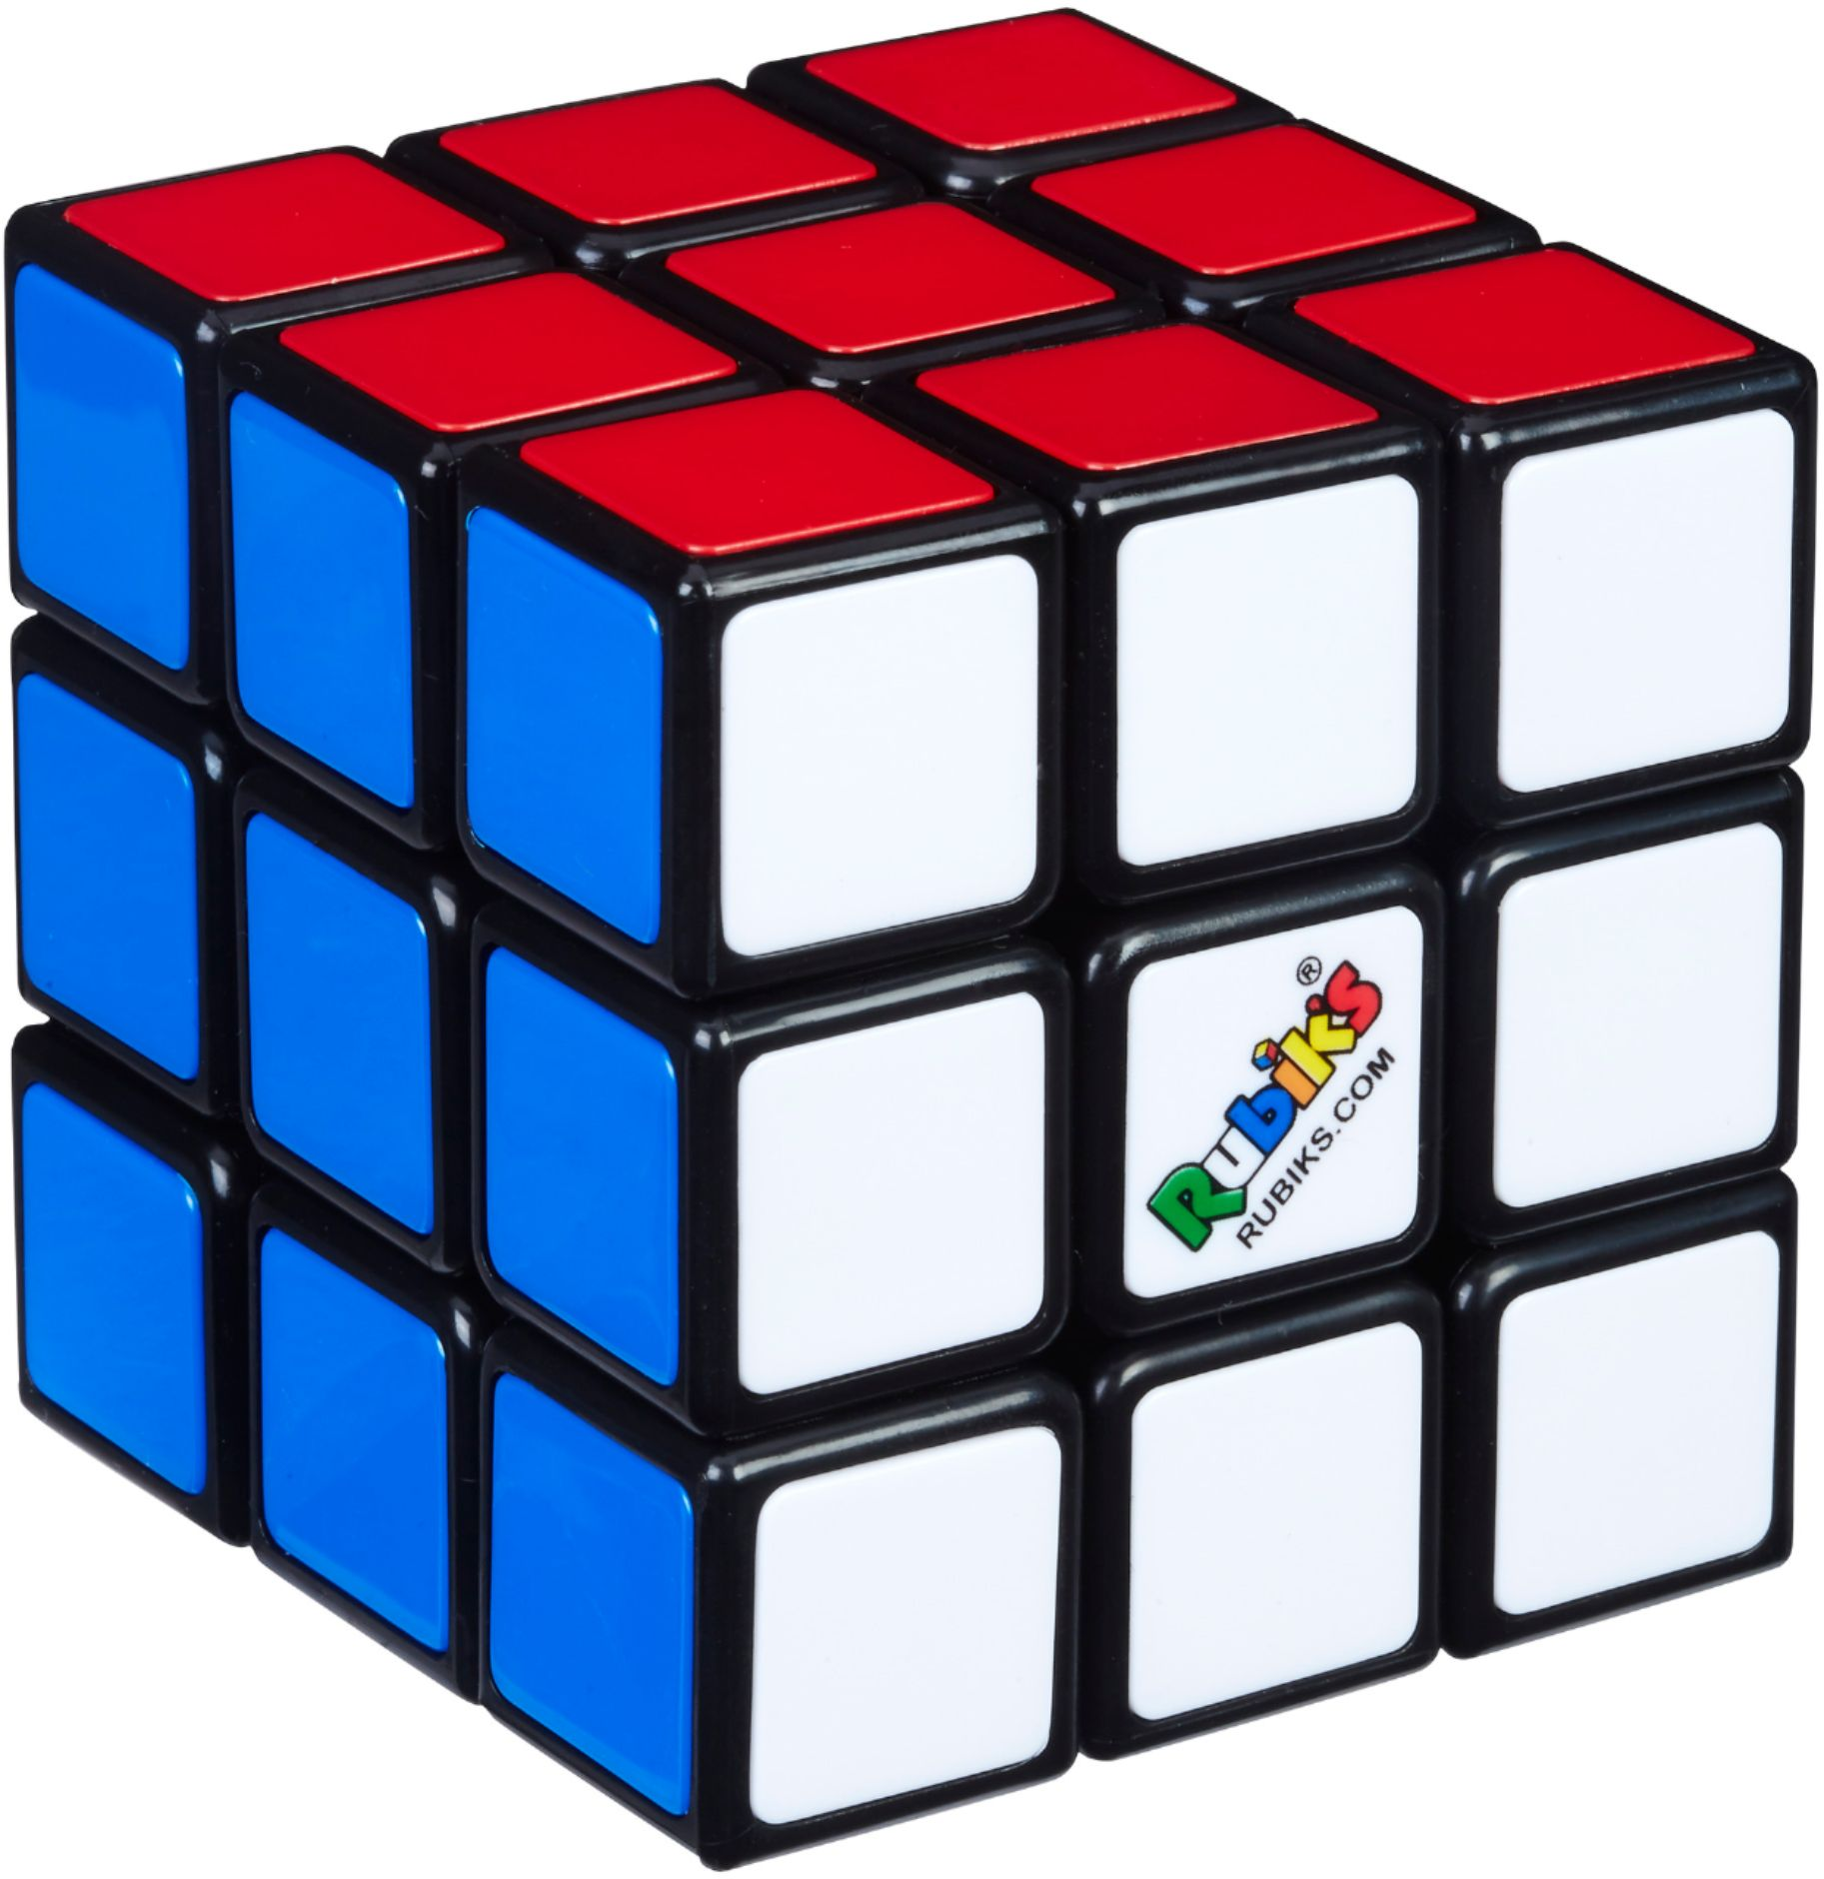

(I then searched on Google about pictures of 3D tic-tac-toe, most of the results have three layers on a 2D surface - like image 1 shows. Image 2 shows a figure of Rubik’s Cube)

Me: I think I can use Java FX to make that 3D Model. OK. So we find out what you need and what should I do. I think that is enough for this interview. We will have more discussions later.

Image 1: <https://www.google.com/url?sa=i&source=images&cd=&ved=2ahUKEwjO-LyQ25bmAhWc_XMBHe2DAHgQjRx6BAgBEAQ&url=https%3A%2F%2Fgithub.com%2Fadamdevigili%2F3D-Tic-Tac-Toe&psig=AOvVaw2rZSiyOzT-mX9SXjb1zplS&ust=1575367422973378>

Image 2:

<https://www.google.com/url?sa=i&source=images&cd=&ved=2ahUKEwiFh7ar25bmAhUC73MBHfLsCOEQjRx6BAgBEAQ&url=https%3A%2F%2Fwww.mindgamesbrisbane.com%2Fproduct%2Frubiks-cube-3x3-2%2F&psig=AOvVaw0asJk88TzvPVsrfrWEPLZC&ust=1575367478881867>